Comoros

## Respect for rule of law (ROL) data

The data set shows the data on the respect of the rule of law for the country.

## # A tibble: 19 x 5  
## country iso3c date ruleOfLaw ruleOfLawCategory4   
## <chr> <chr> <dbl> <dbl> <chr>   
## 1 Comoros COM 1996 -0.879 ROL moderately disrespected  
## 2 Comoros COM 1998 -1.09 ROL highly disrespected   
## 3 Comoros COM 2000 -1.29 ROL highly disrespected   
## 4 Comoros COM 2002 -0.951 ROL moderately disrespected  
## 5 Comoros COM 2003 -0.869 ROL moderately disrespected  
## 6 Comoros COM 2004 -1.02 ROL highly disrespected   
## 7 Comoros COM 2005 -0.995 ROL moderately disrespected  
## 8 Comoros COM 2006 -0.953 ROL moderately disrespected  
## 9 Comoros COM 2007 -1.01 ROL highly disrespected   
## 10 Comoros COM 2008 -1.03 ROL highly disrespected   
## 11 Comoros COM 2009 -1.13 ROL highly disrespected   
## 12 Comoros COM 2010 -1.05 ROL highly disrespected   
## 13 Comoros COM 2011 -1.00 ROL highly disrespected   
## 14 Comoros COM 2012 -1.02 ROL highly disrespected   
## 15 Comoros COM 2013 -0.937 ROL moderately disrespected  
## 16 Comoros COM 2014 -0.892 ROL moderately disrespected  
## 17 Comoros COM 2015 -0.815 ROL moderately disrespected  
## 18 Comoros COM 2016 -0.999 ROL moderately disrespected  
## 19 Comoros COM 2017 -1.05 ROL highly disrespected

## Respect for rule of law (ROL) trend

The plot shows the trend of the respect for the rule of law for the country.

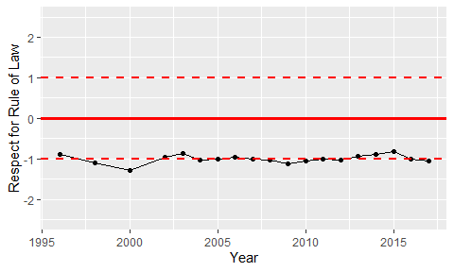

Trend of the Respect for the Rule of Law